AE Laboratory Practice Report

EASE Theater Design

Student: Blindu Andrei-Samuel

Student: Rakovec Maj





**Overview**

The purpose of this laboratory project was to plan a theater hall which met certain acoustic standards. We have designed a theater with a total number of 429 seats, a total room volume (excluding the mouth of the stage) of 2184 m3 , which gives us a ratio V/N = 5.08 . We have also included 3 reflector panels.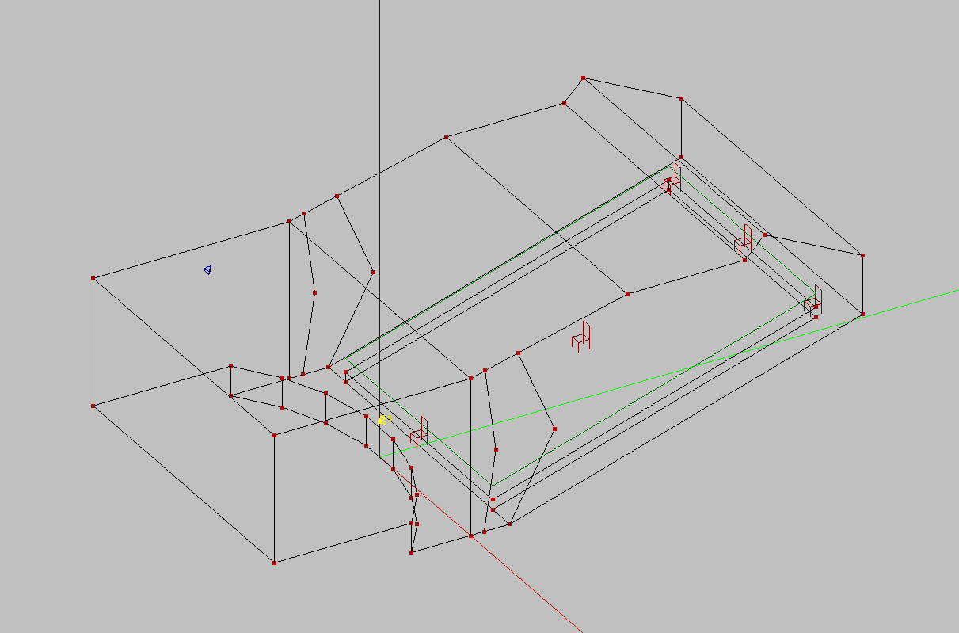



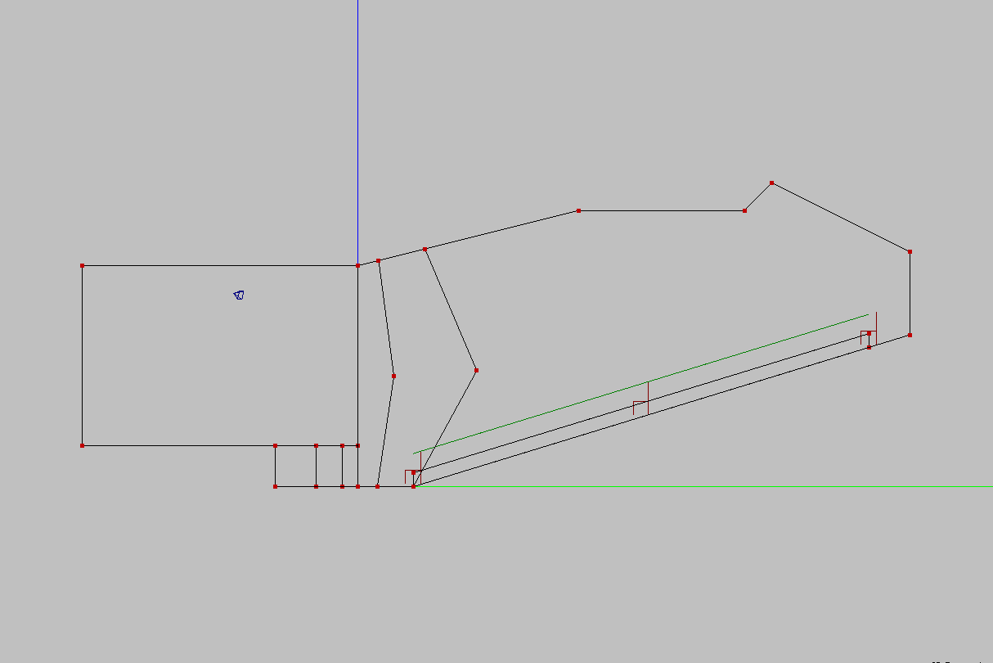



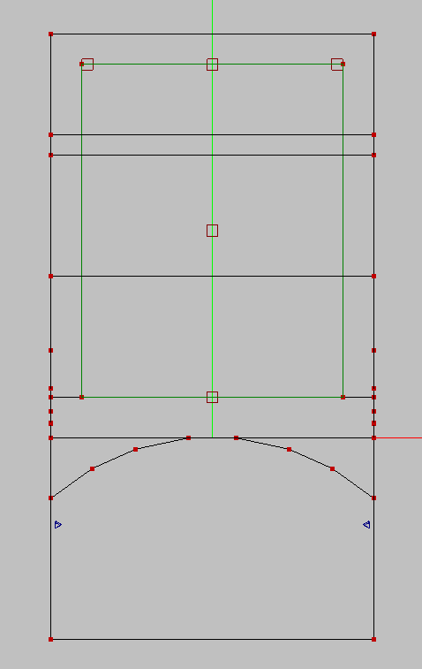



**REFLECTIVE PANELS**

* For reflective panels we decided to change the structure and materials of the roof. There are three areas on top of the theater that reflect a beam of sound directly to the last row.
* the purpose of reflective panels is more even distribution of sound throughout the space
* For reflector panels we had to use materials with low sound absorption coefficient. (smooth finish on lath).

[C = source]

[D = audience - back row]

[K, G, I = points on reflective panels, reflecting sound to the last row]

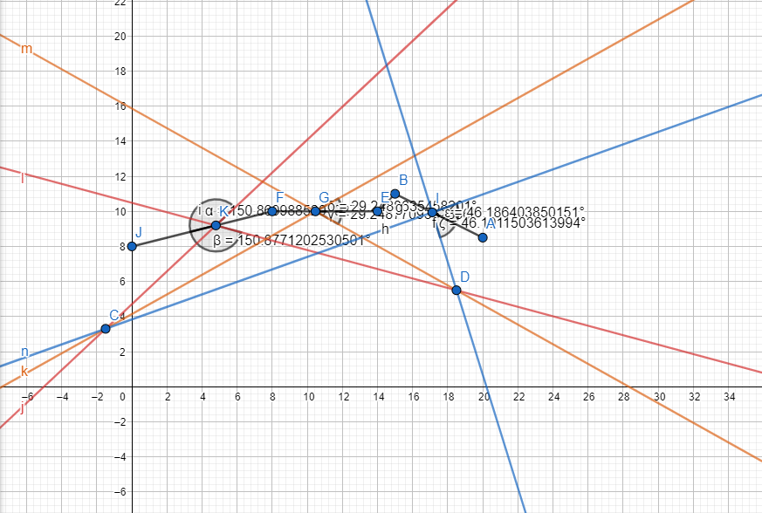

**SOUND REFLECTANCE**

Here is a list of the corresponding materials used for each surface, organized by their respective absorption coefficients:

* low absorption materials: roof, backwall, sidewalls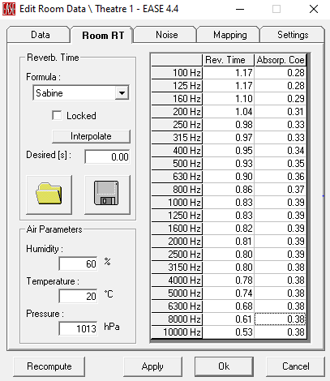
* medium abs materials: floor, stage floor, audience
* high absorption materials: stage mouth - front wall, sidewall absorbers
* diffusion materials: stage back wall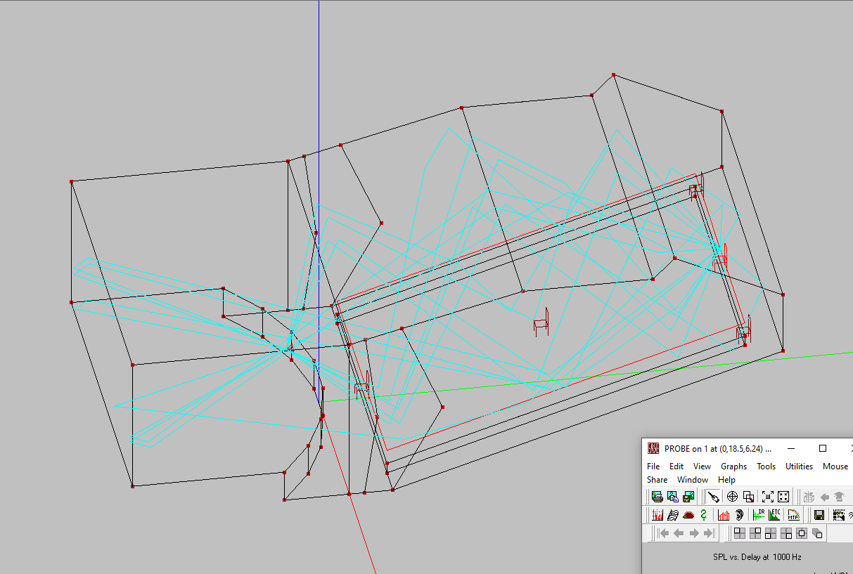

Ray Tracing of this theater design matches the criteria; the reverberation time doesn’t exceed 1,2s and at 4KHz doesn’t fall below 0,8s.

The mouth of the stage is covered with absorption material of which absorption coefficient linearly grows in range between 125Hz and 4KHz from around 0,3 to 0,55.

**REVERBERATION TIME**

Position of the person speaking was set to y=-1,5m and z=3,3m. The artificial speaker used for calculations was an omnidirectional speaker, radiating equal SPLl in all directions.

The room was checked for reflectance delay of 4th order (4 reflections).

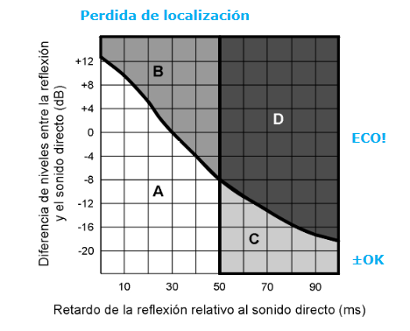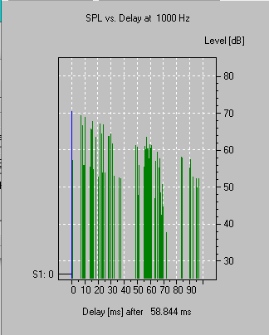

The latencies that do not comply with Haas diagram are caused because of back-wall reflection, some other latencies had to be corrected by adding additional absorption panels on side walls near the stage mouth.

After adding absorption panels, all the frequency and latency spectrum is either in region A or region B.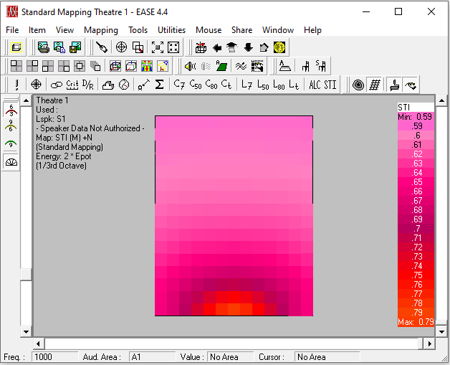

**STI AREA MAP**

The image is showing the 2D top view of the distribution of STI over the audience area. As expected, the STI is higher in areas closer to the stage and lower in areas of back rows, but because of additional reflective panels it is distributed more evenly. The criteria indicated that the STI should always be above 0.6. This design just barely misses the criteria, as it has the lowest STI value of 0.59, but no matter what parameter was changed (inclination of speaker, abs panels) we couldn’t raise the minimum STI value. It may be important to mention that we left everything else as it was in order not to interfere with the RT value.

**AURALISATION**

The process of auralization entails producing an audio file that enables listening to the sound that a selected acoustic source would produce for a listener at a specific location in the room. For this process we have chosen two extreme positions, one in the front row right next to the speaker and one in the furthest back point, where speech intelligibility is expected to not be as high. The first row audio file has a lot of reverb as the theater room is pretty big, but no echo interferes and the speech is loud, clear and easy to follow. In the case of the back row, although intelligibility is significantly lower, there are no echoes interfering with a delay of over 5ms, so the experience of the listener is not disrupted.

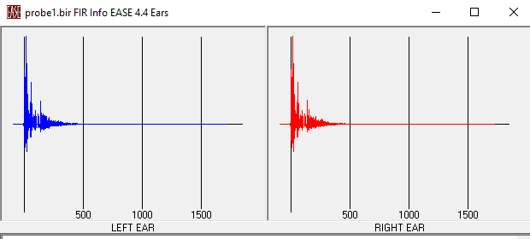

This is the Ears diagram for the back row position.

**ADAPTABILITY TO CINEMA**

A very useful property of this simple theater design we have chosen is that it is very suitable for a cinema room as well. If we were to replace the mouth of the stage with a projection panel, and include two large JBL speakers in the upper corners of the screen, the room acoustic properties would allow for a perfect movie experience:

• A minimum SPL of 90 dB overall for each audience seat.

• Coverage uniformity: within the audience area, there should be no more than a 6 dB differential between the lowest and maximum total SPL.

• Intelligibility: STI ≥ 0.65 everywhere.

